3GPP TS 28.530 V15.1.0 (2018-12)
Technical Specification
3rd Generation Partnership Project;
Technical Specification Group Services and System Aspects;Management and orchestration;
Concepts, use cases and requirements
(Release 15)


The present document has been developed within the 3rd Generation Partnership Project (3GPP TM) and may be further elaborated for the purposes of 3GPP..
The present document has not been subject to any approval process by the 3GPP Organizational Partners and shall not be implemented.
This Specification is provided for future development work within 3GPP only. The Organizational Partners accept no liability for any use of this Specification.
Specifications and Reports for implementation of the 3GPP TM system should be obtained via the 3GPP Organizational Partners' Publications Offices.

Keywords
Magagement,orchestration,use cases, requirements
3GPP
Postal address

3GPP support office address
650 Route des Lucioles - Sophia Antipolis
Valbonne - FRANCE
Tel.: +33 4 92 94 42 00 Fax: +33 4 93 65 47 16
Internet
http://www.3gpp.org
Copyright Notification
No part may be reproduced except as authorized by written permission.
The copyright and the foregoing restriction extend to reproduction in all media.

© 2018, 3GPP Organizational Partners (ARIB, ATIS, CCSA, ETSI, TSDSI, TTA, TTC).
All rights reserved.

UMTS™ is a Trade Mark of ETSI registered for the benefit of its members
3GPP™ is a Trade Mark of ETSI registered for the benefit of its Members and of the 3GPP Organizational Partners
LTE™ is a Trade Mark of ETSI registered for the benefit of its Members and of the 3GPP Organizational Partners
GSM® and the GSM logo are registered and owned by the GSM Association
Contents
Foreword 5
Introduction 5
1 Scope 6
2 References 6
3 Definitions and abbreviations 6
3.1 Definitions 6
3.2 Abbreviations 7
4 Concepts and background 7
4.1 General concepts 7
4.1.1 Management of 5G networks and network slicing 7
4.1.2 Types of communication services 8
4.1.3 Communication services using network slice instances 8
4.1.4 Communication services requirements 9
4.1.5 NSI Lifecycle and relationship to service instances 10
4.1.6 Network Slice as a Service (NSaaS) 10
4.1.7 Network Slices as NOP internals 11
4.1.8 Network slice delivery concepts 12
4.2 Principles 12
4.2.1 General Principles 12
4.2.2 Principles of network slicing management framework 12
4.3 Management aspects of a network slice instance 13
4.3.1 Introduction 13
4.3.2 Preparation 14
4.3.3 Commissioning 14
4.3.4 Operation 14
4.3.5 Decommissioning 14
4.4 Managed network slice concepts 14
4.4.1 General 14
4.5 Network slice subnet concepts 15
4.6 Network slice subnet template concepts 15
4.7 Coordination with management systems of non-3GPP parts 15
4.8 Roles related to 5G networks and network slicing management 16
5 Business level requirements 17
5.1 Requirements 17
5.1.1 General requirements 17
5.1.2 Network slicing management 18
5.1.3 CM requirements 19
5.2 Actor roles 20
5.3 Telecommunication resources 20
5.4 High-level use cases 20
5.4.1 Network slicing supporting communication services 20
5.4.2 Provisioning of a network slice instance 21
5.4.3 Provisioning of a network slice subnet instance 22
5.4.4 Performance management of a Network Slice Instance (NSI) 22
5.4.5 Performance management of a Network Slice Subnet Instance (NSSI) 23
5.4.6 Report fault management data of a network slice instance 23
5.4.7 Report fault management data of a network slice subnet instance 24
5.4.8 Multiple operator support for network slicing 24
5.4.9 Manage network slice with agreed performance 25
5.4.10 Communication services using network with or without slicing 25
5.4.11 Exposure of network slice management data for network slice as a service case 26
5.4.12 Exposure of network slice management capability 26
5.4.13 To modify the network slice instance due to changed demand 27
5.4.14 Management data analytics for 5G networks 27
5.4.15 Capacity management of Network Slice Instances (NSIs) and Network Slice Subnet Instances (NSSIs) 28
Annex A (informative): Change history 29

Foreword
This Technical Specification has been produced by the 3rd Generation Partnership Project (3GPP).
The contents of the present document are subject to continuing work within the TSG and may change following formal TSG approval. Should the TSG modify the contents of the present document, it will be re-released by the TSG with an identifying change of release date and an increase in version number as follows:
Version x.y.z
where:
x the first digit:
1 presented to TSG for information;
2 presented to TSG for approval;
3 or greater indicates TSG approved document under change control.
y the second digit is incremented for all changes of substance, i.e. technical enhancements, corrections, updates, etc.
z the third digit is incremented when editorial only changes have been incorporated in the document.

Introduction
Network slicing is a key feature for 5G. Network slicing is a paradigm where logical networks/partitions are created, with appropriate isolation, resources and optimized topology to serve a purpose or service category (e.g. use case/traffic category, or for MNO internal reasons) or customers (logical system created "on demand").

1 Scope
The present document specifies the concepts, use cases and requirements for management of network slicing in mobile networks. The 3GPP management system directly manages only the parts of the network that consist of network functions specified in 3GPP (e.g. 5G RAN, 5G CN and IMS). For the network functions specified by other SDOs, the management impact of network slicing is addressed as required. For example, regarding the Transport Network (TN) part supporting connectivity within and between CN and RAN parts, 3GPP management system may provide link requirements (e.g. topology, QOS parameters) to the TN management system.

2 References
The following documents contain provisions which, through reference in this text, constitute provisions of the present document.
- References are either specific (identified by date of publication, edition number, version number, etc.) or non-specific.
- For a specific reference, subsequent revisions do not apply.
- For a non-specific reference, the latest version applies. In the case of a reference to a 3GPP document (including a GSM document), a non-specific reference implicitly refers to the latest version of that document in the same Release as the present document.
[1] 3GPP TR 21.905: "Vocabulary for 3GPP Specifications".
[2] 3GPP TS 22.261 "Service requirements for next generation new services and markets".
[3] 3GPP TS 23.501: " System Architecture for the 5G system".
[4] 3GPP TS 38.401 "NG-RAN; Architecture description".

3 Definitions and abbreviations

3.1 Definitions
For the purposes of the present document, the terms and definitions given in 3GPP TR 21.905 [1] and the following apply. A term defined in the present document takes precedence over the definition of the same term, if any, in 3GPP TR 21.905 [1].
network slice: Defined in 3gpp TS 23.501 v1.4.0 [3].
network slice instance: Defined in 3GPP TS 23.501 V1.4.0 [3].
network slice subnet: a representation of the management aspects of a set of Managed Functions and the required resources (e.g. compute, storage and networking resources).
network slice subnet instance: an instance of Network Slice Subnet representing the management aspects of a set of Managed Function instances and the used resources (e.g. compute, storage and networking resources).
Network Slice Subnet Template (NSST): subset of attributes' values used for creation of instances of Network Slice Subnet Information Object Class.
Note: Network Slice Subnet Information Object Class describes the structure (i.e. contained components and connectivity between them) and configuration of a network slice subnet, as well as network capability.

3.2 Abbreviations
For the purposes of the present document, the abbreviations given in 3GPP TR 21.905 [1] and the following apply. An abbreviation defined in the present document takes precedence over the definition of the same abbreviation, if any, in 3GPP TR 21.905 [1].
CSC Communication Service Customer
CSP Communication Service Provider
DN Data Network
MNO Mobile Network Operator
NOP Network Operator
NSaaS Network Slice as a Service
NSaasC Network Slice as a Service Customer
NSaaSP Network Slice as a Service Provider
NSC Network Slice Customer
NSI Network Slice Instance
NSP Network Slice Provider
NSS Network Slice Subnet
NSSI Network Slice Subnet Instance
NSST Network Slice Subnet Template
TN Transport Network

4 Concepts and background

4.1 General concepts

4.1.1 Management of 5G networks and network slicing
5G system consists of 5G Access Network (AN), 5G Core Network and UE, see TS 23.501 [3].
5G system is expected to be able to provide optimized support for a variety of different communication services, different traffic loads, and different end user communities, see clause 4 of TS 22.261 [2]. For example, the communication services using network slicing may include:
- V2X services
The 5G system aims to enhance its capability to meet KPIs that emerging V2X applications require. For these advanced applications, the requirements, such as data rate, reliability, latency, communication range and speed, are made more stringent, see clause 4 of TS 22.261 [2].
- 5G seamless eMBB service with FMC
As one of the key technologies to enable network slicing, fixed mobile convergence (FMC) which includes wireless-to-the-everything (WTTx) and fibre-to-the-everything (FTTx), is expected to provide native support for network slicing. For optimization and resource efficiency, the 5G system will select the most appropriate 3GPP or non-3GPP access technology for a communication service, potentially allowing multiple access technologies to be used simultaneously for one or more services active on a UE, see clause 6.3 of TS 22.261 [2].
- massive IoT connections
Support for massive Internet of Things (mIoT) brings many new requirements in addition to MBB enhancements, see clause 4 of TS 22.261 [2]. Communication services with massive IoT connections such as smart households, smart grid, smart agriculture and smart meter will require the support of a large number and high density IoT devices to be efficient and cost effective, see TS 23.501 [3]. Operators can use one or more network slice instances to provide these communication services, which require similar network characteristics, to different vertical industries.
The next generation 3GPP management system is expected to support the management of 3GPP 5G system and 3GPP legacy systems.
3GPP management system directly manages 3GPP managed network components (e.g. 5G RAN, 5G CN). For non-3GPP domains (e.g. DCN, TN), 3GPP management system needs to coordinate with the corresponding management systems of the non-3GPP domains.

4.1.2 Types of communication services
Communication services offered by Communication Service Providers (CSPs) to Communication Service Customers (CSCs) are of various categories, among which:
- Business to consumer (B2C) services, e.g. mobile web browsing, 5G voice, Rich Communication Services, etc.
- Business to business (B2B) services, e.g. Internet access, LAN interconnection, etc.
- Business to household (B2H) services, e.g. Internet access, MBMS, VOIP, VPN, etc.
- Business to business to everything (B2B2X) services: e.g. services offered to other CSPs (e.g. international roaming, RAN sharing, etc.) offering themselves communication services to their own customers. B2B2X service type includes B2B2 applied recursively, i.e. B2B2B, B2B2B2B, etc.
NOTE: How to derive different network slice related requirements from different categories of communication services is not in the scope of the present document.
A communication service offered by CSPs can include a bundle of specific B2C, B2B, B2H or B2B2X type of services. Taking as an example the B2C type of services, a bundle could include: data (for mobile web browsing), voice (through 5G voice), and messaging (via Rich Communication Services). In this case, each one of the individual B2C may be fulfilled by different PDU connectivity services provided via corresponding PDU sessions.

4.1.3 Communication services using network slice instances
As an example, a variety of communication services instances provided by multiple NSI(s) are illustrated in the figure 4.1.3.1. Figure 4.1.3.1 is only for illustrative purposes to highlight the combination and relationship of Communication Services to Network Slices without depicting any UE. An actual network slice deployment offering communication services to UEs will need to comply with the 5G system architecture defined in TS 23.501 [3] and TS 38.401 [4].

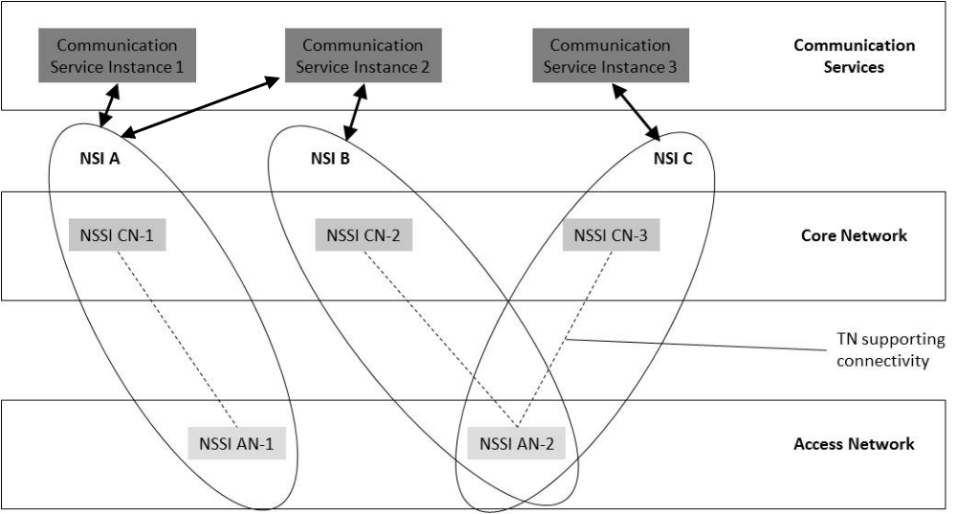
Figure 4.1.3.1: A variety of communication services instances provided by multiple NSIs
Different NSIs (NSI A, NSI B and NSI C) contains NFs (e.g. belonging to NSSI AN-1, NSSI AN-2, NSSI CN-1, NSSI CN-2 and NSSI CN-3) as well as all information relevant to the interconnections between these NFs. Different Communication Service Instances are provided by CSP through using different NSIs. For example, Communication Service Instance 1 and Communication Service Instance 2 use NSI A which contains dedicated NSSIs (NSSI CN-1 and NSSI AN-1), Communication Service Instance 3 uses NSI C which contains a dedicated NSSI (NSSI CN-3) and an NSSI (NSSI AN-2) shared with NSI B.

4.1.4 Communication services requirements
eMBB service type aims at supporting high data rates and high traffic densities as outlined in TS 22.261 [2], Table 7.1-1 "Performance requirements for high data rate and traffic density scenarios". URLLC service type aims at supporting the requirements in TS 22.261 [2], Table 7.2.2-1 "Performance requirements for low-latency and high-reliability services." related to high reliability and low latency scenarios. mIoT service type aims at supporting a large number and high density of IoT devices efficiently and cost effectively, see TS 23.501 [3].
Depending on the service type (eMBB, URLLC, mIoT), different service types may include different network slice related requirements, for example:
- Area traffic capacity requirement
- Charging requirement
- Coverage area requirement
- Degree of isolation requirement
- End-to-end latency requirement
- Mobility requirement
- Overall user density requirement
- Priority requirement
- Service availability requirement
- Service reliability requirement
- UE speed requirement

4.1.5 NSI Lifecycle and relationship to service instances
An NSI may support multiple service instances. When a service instance is to be supported, it may trigger an operation phase of the NSI lifecycle for activation or modification(s) of an existing NSI, or it may trigger a commissioning phase of the NSI lifecycle for creation of a new NSI. When a service instance no longer needs to be supported by an NSI, it may trigger an operation phase of the NSI lifecycle for de-activation or modification(s) of an existing NSI, or it may trigger a decommissioning phase of the NSI lifecycle for termination of an existing NSI.

4.1.6 Network Slice as a Service (NSaaS)
Network Slice as a Service (NSaaS) can be offered by a CSP to its CSC in the form of a communication service. This service allows CSC to use the network slice instance as the end user or optionally allows CSC to manage the network slice instance as manager via management exposure interface. In turn, these CSC can play the role of CSP and offer their own services (e.g. communication services) on top of the network slice instance. For example, a network slice customer can also play the role of NOP and could build their own network containing the network slice offered by the operator. In this model, both CSP offering NSaaS and CSC consuming NSaaS have the knowledge of the existence of network slice instances. Depending on service offering, CSP offering NSaaS may impose limits on the NSaaS characteristics exposure to the CSC, and the CSC can manage the network slice instance according to NSaaS characteristics exposed and agreed upon limited level of management by the CSP.
The NSaaS offered by the CSP could be characterized by certain properties, e.g.
- radio access technology,
- bandwidth,
- end-to-end latency,
- reliability,
- guaranteed / non-guaranteed QoS,
- security level, etc.
Figure 4.1.6.1 illustrates some examples on how network slices can be utilized to deliver communication services, including Network Slice as a Service:
a) A Network Slice as a Service is provided to CSC-A by CSP-A. Unlike the communication service delivered to end customers, in NSaaS, the communication service is the actual network slice.
b) CSC-A can use the offered network slice by CSP-A or may add additional network functions to the offered NSaaS to provide a new network slice to CSP-B. In this case, CSC-A plays the role of NOP-B and builds his own network.
c) CSP-B can use the offered network slice built by CSC-A / NOP-B to deliver Communication Services to end customers (CSC-B).

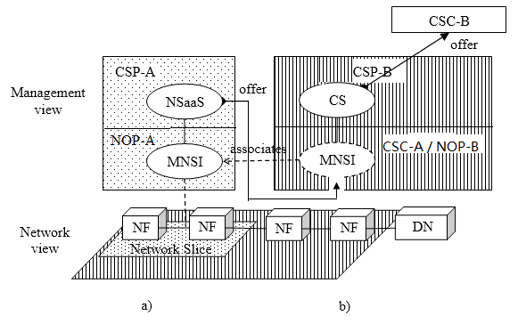
NSI
NSI
Figure 4.1.6.1: Examples of Network Slice as a Service being utilized to deliver communication services to end customers

4.1.7 Network Slices as NOP internals
In the "Network Slices as NOP internals" model, network slices are not part of the CSP service offering and hence are not visible to CSCs. However, the NOP, to provide support to communication services, may decide to deploy network slices, e.g. for internal network optimization purposes. This model allows CSC to use the network as the end user or optionally allows CSC to monitor the service status.
The CSP should be able to provide the service status information (e.g. service performance, fault information, traffic data, etc) to CSC via the management exposure interface.
Figure 4.1.7.1 illustrates an example on how network slices can be utilized to deliver communication services:
a) A network slice is used as NOP internal, and CSP delivers communication services to end customers (CSC).
b) The CSC should be able to monitor the network and service status information (e.g. service performance, fault information, traffic data, etc.) provided by CSP.
DN
NF
NF
Network Slice
Network view
Management view
CSP
NOP

CSC
NSI
CS
offer
a)
Figure 4.1.7.1: Examples of network slice as NOP internals

4.1.8 Network slice delivery concepts
Network slice instances are provided in different compositions to the customer which may include access to different management capabilities and network slice instance provisioning procedures for the customer.
For example, a network slice may be delivered
a) to meet customer's communication service requirements without any exposure of internal NSI structures (applicable to both individual subscribers and NSaaS); or
b) to meet the network slice instance requirements, with some exposure of the internal NSI structures (e.g. NFs, topology, etc.) and with some network monitoring capability as enabled by the provider; or
c) to meet the network slice instance requirements with some exposure of the internal NSI structures (e.g. NFs) with some management capabilities as enabled by the provider.

4.2 Principles

4.2.1 General Principles
The 5G network management framework is built upon the following principles:
a. Support management of 5G networks with or without network slicing features.
b. Support management across multiple operator's scenario.
c. Support interaction with non-3GPP management system.
d. Support service-based management.

4.2.2 Principles of network slicing management framework
The 5G network slicing management framework is built upon the following principles:
1. Standardized management service interfaces of the network slicing management services.
2. Standardized management service interfaces of network function management services.
3. Multi-vendor interaction utilizing the standardized management service interfaces of the network slicing management services, as well as the standardized management service interfaces of the network function related management functions.
4. A simple network slicing set of management functions to simplify the management of network function(s) from the slicing management point-of-view.
5. Network slicing management services are capable to support various Network Operator deployment options to support diverse use cases, and a set of generic management services applicable to all kinds of network functions.
Figure 4.2.2.1 illustrates the basic principle of standardized management services for network slicing management related capabilities.
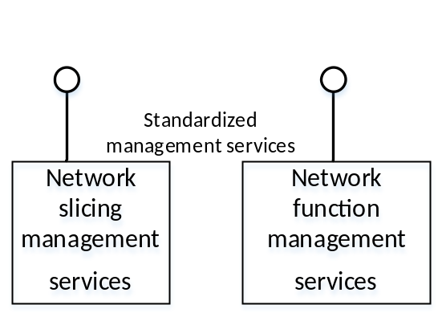
Figure 4.2.2.1: Standardized network slicing management services and network function management services

4.3 Management aspects of a network slice instance

4.3.1 Introduction
This clause describes management aspects of a Network Slice Instance, which can be described by the four phases shown in Figure 4.3.1.1, the phases are:
- Preparation
- Commissioning
- Operation
- Decommissioning
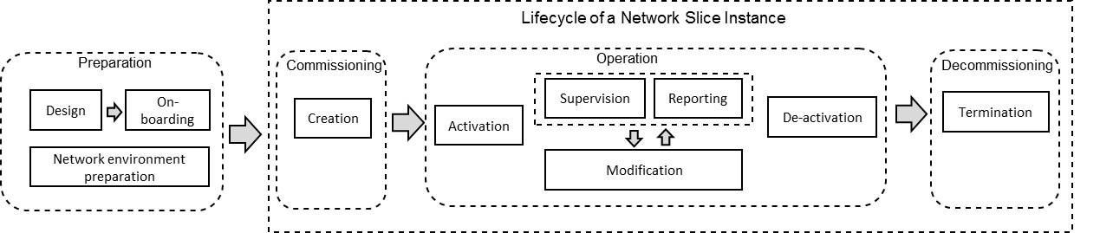

Figure 4.3.1.1: Management aspects of network slice instance
Each phase, described in subsequent clauses, defines high level tasks and should include appropriate verification of the output of each task.

4.3.2 Preparation
In the preparation phase the NSI does not exist. The preparation phase includes network slice template design, network slice capacity planning, on-boarding and, evaluation of the network slice requirements, preparing the network environment and other necessary preparations required to be done before the creation of an NSI.

4.3.3 Commissioning
NSI provisioning in the commissioning phase includes creation of the NSI. During NSI creation all needed resources are allocated and configured to satisfy the network slice requirements. The creation of an NSI can include creation and/or modification of the NSI constituents.

4.3.4 Operation
The Operation phase includes the activation, supervision, performance reporting (e.g. for KPI monitoring), resource capacity planning, modification, and de-activation of an NSI.
Activation makes the NSI ready to support communication services.
Resource capacity planning includes any actions that calculates resource usage based on an NSI provisioning, and performance monitoring and generates modification polices as a result of the calculation.
NOTE: Automation of resource capacity planning is out of scope of the present document.
NSI modification could be including e.g. capacity or topology changes. The modification can include creation or modification of NSI constituents. NSI modification can be triggered by receiving new network slice requirements or as the result of supervision/reporting
The deactivation includes actions that make the NSI inactive and stops the communication services.
Network slice provisioning actions in the operation phase involves activation, modification and de-activation of an NSI.

4.3.5 Decommissioning
Network slice instance provisioning in the decommissioning phase includes decommissioning of non-shared constituents if required and removing the NSI specific configuration from the shared constituents. After the decommissioning phase, the NSI is terminated and does not exist anymore.

4.4 Managed network slice concepts

4.4.1 General
From a management point of view a network slice instance is complete in the sense that it includes all the managed function instances, with their supporting resources, to provide a certain set of communication services to serve a certain business purpose.
The following concepts are related to network slicing management:
a. Services which are supported by network slice instances
b. Network Slice instances and networks composed of PNF, VNF or both
c. Network function (PNFs, VNFs)
d. Resources which support the network (e.g. virtualized resource, non-virtualized resource)
The management aspects of the network slice instance are represented by management of the CN part, and AN part which are directly managed by the 3GPP management system, and management of non-3GPP part which is not directly managed by the 3GPP management system. The non-3GPP part includes TN parts. The 3GPP management system provides the network slice requirements to the corresponding management systems of those non-3GPP parts, e.g. the TN part supports connectivity within and between CN and AN parts. For the TN part, the 3GPP management system provides the TN topology requirements and individual TN links' QoS attributes requirements to the TN management system.
The 3GPP management system maintains the network topology and the related QOS requirements.
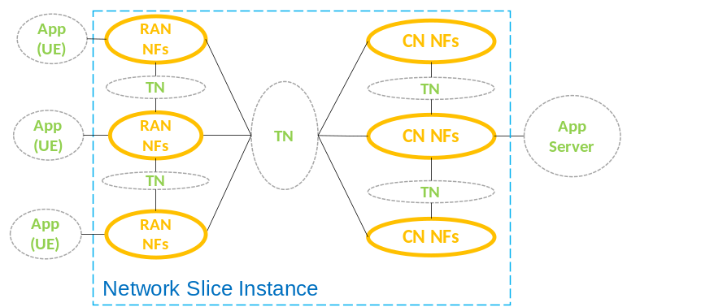
Figure 4.4.1.1: Example of an NSI

4.5 Network slice subnet concepts
The Network Slice Subnet Instance (NSSI) represents a group of network function instances (including their corresponding resources) that form part or complete constituents of a Network Slice Instance (NSI). The grouping of the network functions allows the management of each group of network functions to be conducted independently of the network slice instance.
The Network Slice Subnet concepts include the following aspects:
- An NSSI constituent may include Managed Function(s) directly and other constituent NSSI(s).
- An NSSI may be shared by two or more NSIs, this is called a shared constituent of NSI.
- An NSSI may be shared by two or more NSSI(s), this is also called a shared constituent of NSSI.
- An NSSI that is dedicated to one NSI and is not shared as a constituent by two or more NSSI(s) is called a non-shared NSSI.
- An NSSI may contain instances of CN Managed Functions only, or instances of AN Managed Functions only, or any combination thereof.
- An NSSI may additionally have information representing a set of links with capacities to provide connection between managed functions.
- The resources used, and whose management aspects are represented by an NSSI comprise physical and logical resources. In case of virtualization, virtualized resources may be used.

4.6 Network slice subnet template concepts
The network slice subnet instance is created using a Network Slice Subnet Template (NSST) and instance-specific information. The NSST can be used for creating different network slice subnet instances with different instance-specific information.

4.7 Coordination with management systems of non-3GPP parts
When providing an end to end communication service, the network may use non-3GPP parts (e.g. Data centre network (DCN), Transport network (TN)) in addition to the network components defined in 3GPP. Therefore, in order to ensure the performance of a communication service according to the business requirements, the 3GPP management system has to coordinate with the management systems of the non-3GPP parts (e.g., MANO system) when preparing a network slice instance for this service. This coordination may include obtaining capabilities of the non-3GPP parts and providing the slice specific requirements and other requirements on the non-3GPP parts. Figure 4.7.1 illustrates an example for the coordination with management of TN part (e.g., directly or via MANO system).
The 3GPP management system identifies the requirements on involved network domains, such as RAN, CN and non-3GPP parts of a slice by deriving them from the customer requirements to the services supported by the network slice. The derived requirements are sent to the corresponding management systems. The coordination may also include related management data exchange between those management systems and the 3GPP management system.
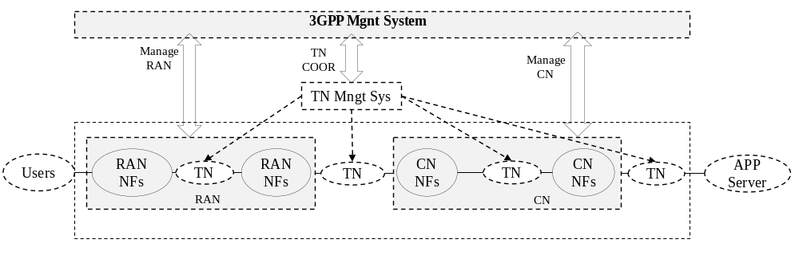
Figure 4.7.1: Example of coordination between 3GPP and TN management systems

4.8 Roles related to 5G networks and network slicing management
In the context of next generation networks, responsibilities regarding operations have to be clearly defined and assigned to roles. The roles related to 5G networks and network slicing management include:
- Communication Service Customer (CSC): Uses communication services.
- Communication Service Provider (CSP): Provides communication services. Designs, builds and operates its communication services. The CSP provided communication service can be built with or without network slice.
- Network Operator (NOP): Provides network services. Designs, builds and operates its networks to offer such services.
- Network Equipment Provider (NEP): Supplies network equipment to network. For sake of simplicity, VNF Supplier is considered here as a type of Network Equipment Provider. This can be provided also in the form of one or more appropriate VNF(s).
- Virtualization Infrastructure Service Provider (VISP): Provides virtualized infrastructure services. Designs, builds and operates its virtualization infrastructure(s). Virtualization Infrastructure Service Providers may also offer their virtualized infrastructure services to other types of customers including to Communication Service Providers directly, i.e. without going through the Network Operator.
- Data Centre Service Provider (DCSP): Provides data centre services. Designs, builds and operates its data centres.
- NFVI Supplier: Supplies network function virtualization infrastructure to its customers.
- Hardware Supplier: Supplies hardware.
Depending on actual scenarios:
- each role can be played by one or more organizations simultaneously;
- an organization can play one or several roles simultaneously (for example, a company can play CSP and NOP roles simultaneously).
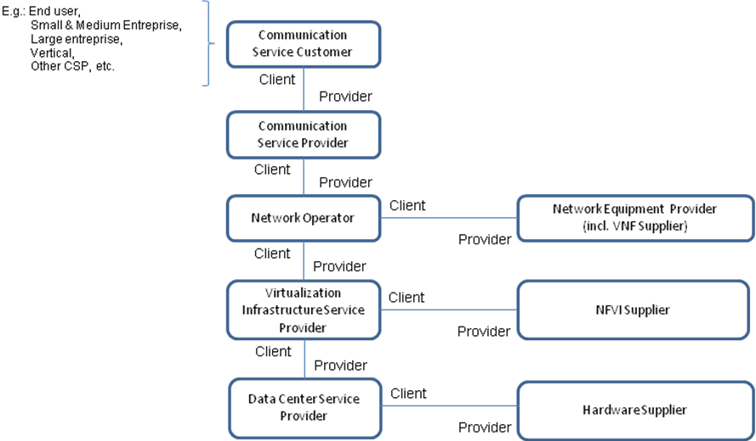
Figure 4.8.1: High-level model of roles
In case of Network Slice as a Service (NSaaS) (cf. clause 4.1.6), the Communication Service Provider (CSP) role can be refined into NSaaS Provider (NSaaSP) role – or, in short, Network Slice Provider (NSP) - and the Communication Service Customer (CSC) role can be refined into NSaaS Customer (NSaaSC) role – or, in short, Network Slice Customer (NSC). A NSC can, in turn, offer its own communication services to its own customers, being thus CSP at the same time.
4.9 Management data analytics for 5G networks
The 5G networks have capability to support a variety of communication services, such as IoT and eMBB. The increasing flexibility of the networks to support services with diverse requirements may present operational and management challenges. 5G networks management system can therefore benefit from management data analytics for improving networks performance and efficiency to accommodate and support the diversity of services and requirements. The management data analytics utilize the collection of network data (including e.g. service, slicing and/or network functions related data) to perform analytics in order to assist and complement management services for an optimum network performance and service assurance.

5 Business level requirements

5.1 Requirements

5.1.1 General requirements
REQ-5GNS-CON-01 The network slicing management architecture shall allow any deployment options within the Network Operator's domain.
REQ-5GNS-CON-02 The set of network slicing management functions shall be generic to all kinds of network function and network function provider.
REQ-5GNS-CON-05 The network slicing management architecture shall provide capabilities to manage the total view of all created slice instances.
REQ-5GNS-CON-06 The network slicing management architecture should provide management capabilities that are dedicated to each network slice instance. The instance management dedicated to a network slice instance shall work independently from the instance management dedicated to another network slice instance.
REQ-5GNS-CON-07 The network slicing management architecture shall allow managing multiple network slice instances simultaneously or independently along with their lifecycle.
REQ-5GNS-CON-08 The 3GPP management system shall have the capability to determine to use network with or without slicing based on network related requirements.
REQ-5GNS-CON-09 The 3GPP management system shall, when given the capacity increase or decrease of a network slice instance, be able to calculate the capacity increase or decrease of a RAN slice subnet, CN slice subnet and derive corresponding requirements for the TN part that support the network slice instance.
REQ-5GNS-CON-10 The 3GPP management system shall be able to modify the capacity of a RAN slice subnet to a given value.
REQ-5GNS-CON-11 The 3GPP management system shall be able to modify the capacity of a CN slice subnet to a given value.
REQ-5GNS-CON-12 The 3GPP management system shall be able to communicate the TN requirements corresponding to the network slice capacity change.
REQ-5GNS-CON-13 The 3GPP management system shall be able to provide management data analytics to authorized consumers.
REQ-5GNS-CON-14 The 3GPP management system shall be able to collect and analyse relevant management data.

5.1.2 Network slicing management
REQ-3GPPMS-CON-01 The 3GPP management system shall have the capability to create a new or use an existing network slice instance according to the communication service requirements.
REQ-3GPPMS-CON-02 The 3GPP management system shall have the capability to translate the communication service requirements to network slice related requirements.
REQ-3GPPMS-CON-03 The 3GPP management system shall have the capability to create a new or use an existing network slice instance according to the network slice related requirements.
NOTE: The network slice related requirements include requirements such as: area traffic capacity, charging, coverage area, degree of isolation, end-to-end latency, mobility, overall user density, priority, service availability, service reliability, UE speed.
REQ-3GPPMS -CON-04 The 3GPP management system shall be able to create a network slice instance.
REQ-3GPPMS -CON-05 The 3GPP management system shall have the capability to monitor the network slice related data and provide the agreed data to an authorized consumer.
REQ-3GPPMS -CON-06 The 3GPP management system shall be able to create a network slice subnet instance.
REQ-3GPPMS-CON-07 The 3GPP management system shall be able to evaluate the feasibility of providing a new NSI which does not impact with the existing NSI(s).
REQ-3GPPMS-CON-07a The 3GPP management system should have the capability of allocating the resources of NSIs according to the priority.
REQ-3GPPMS-CON-08 The 3GPP management system should have the capability of re-allocating the resources of NSIs according to the priority.
REQ-3GPPMS-CON-09 The 3GPP management system shall be able to manage the NSI lifecycle.
REQ-3GPPMS-CON-10 The 3GPP management system shall be able to provide link requirements related to the network slice (e.g. topology, QOS parameters) to the appropriate management system that handles the TN part related to the slice (e.g. via NFV MANO).
REQ-3GPPMS-CON-11 The 3GPP management system shall be able to report performance measurement data of a network slice instance to the NOP.
REQ-3GPPMS-CON-12 The 3GPP management system shall be able to report performance measurement data of a network slice subnet instance to the NOP.
REQ-3GPPMS-CON-13 The 3GPP management system shall be able to report fault management data of a network slice instance.
REQ-3GPPMS-CON-14 The 3GPP management system shall be able to report fault management data of a network slice subnet instance.
REQ-3GPPMS-CON-15 The 3GPP management system shall be able to activate a network slice instance.
REQ-3GPPMS-CON-16 The 3GPP management system shall be able to de-activate a network slice instance.
REQ-3GPPMS-CON-17 The 3GPP management system shall be able to modify a network slice instance.
REQ-3GPPMS-CON-18 The 3GPP management system shall be able to terminate a network slice instance.
REQ-3GPPMS-CON-19 The 3GPP management system shall be able to activate a network slice subnet instance.
REQ-3GPPMS-CON-20 The 3GPP management system shall be able to modify a network slice subnet instance.
REQ-3GPPMS-CON-21 The 3GPP management system shall be able to de-activate a network slice subnet instance.
REQ-3GPPMS-CON-22 The 3GPP management system shall be able to terminate a network slice subnet instance.
REQ-3GPPMS-CON-23 The 3GPP management system shall support slice capacity management.
REQ-3GPPMS -CON-24 The 3GPP management system shall support inter-slice orchestration (e.g., orchestrated provisioning of multiple slices and resolving issues on quality, fault, and anomaly, among multiple slices).
REQ-3GPPMS -CON-25 The 3GPP management system shall support collection and analysis of the status and events of the network slice instance resources for the purpose of fault management.
REQ-3GPPMS -CON-26 The 3GPP management system shall support collection and analysis of the status and events of the network slice instance resources for the purpose of performance management.
REQ-3GPPMS-CON-27 The 3GPP management system shall have the capability of exposing network slice management data for network slice as a service to the authorized consumer.
REQ-3GPPMS -CON-28 The 3GPP management system shall have the capability to differentiate communication services provided by a single NSI when the NSI is used to support multiple communication services.
REQ-3GPPMS -CON-29 The 3GPP management system shall have the capability to perform network slice instance related operations (e.g., performance monitoring) considering requirements for each communication service when the network slice instance is used to support multiple communication services.
REQ-3GPPMS-CON-30 The 3GPP management system shall be able to expose the network slice management services such as performance management, fault supervision and provisioning management to the authorized consumer based on the mutual agreement between consumer and operator.
REQ-3GPPMS-CON-31 The 3GPP management system shall have the capability to expose, based on the mutual agreement between consumer and operator, the network slice assurance services to the authorized consumers.
REQ-3GPPMS-CON-32 The 3GPP management system shall have the capability to expose, based on the mutual agreement between consumer and operator, the network slice control and configuration services to the authorized consumers and to resolve potential conflicts

5.1.3 CM requirements
REQ-3GPPCM-CON-01 The 3GPP management system shall have a capability to configure NF instances.

5.2 Actor roles
Consumers of a network management service. A consumer can be a Network Operator (NOP) or Communication Service Provider (CSP).

5.3 Telecommunication resources
The Telecommunication resources include network management functions and/or the managed network functions/resources.

5.4 High-level use cases

5.4.1 Network slicing supporting communication services
Use case stage | Evolution/Specification | <<Uses>>  Related use
Goal | A communication service provider (CSP) uses the network slicing service provided by operator to offer communication services to end users.
Actors and Roles | A CSP request a NOP to provide a network slice instance
Telecom resources | 3GPP management system
Assumptions | N/A
Pre-conditions | The CSP and the operator negotiate and sign the communication service requirements contract.
Begins when | The CSP declares communication service(s) requirements to the operator. The operator triggers the NSI preparation phase which includes the creation and verification of network slice template(s), the on boarding of these, feasibility check, preparing the necessary network environment, which are used to support the lifecycle of NSIs and any other preparations that are needed in the network.
Step 1 (M) | Based on the requirements (e.g. coverage area, number and distribution of users, traffic demand, mobility, latency, etc.) from the consumer of network slicing service, the operator prepares the corresponding NSI(s).
Step 2 (M) | After the NSI preparation phase, the operator triggers the deployment of an NSI.  1) If the CSP plans to operate services crossing multiple operators' administrative domains, this may require cross-country operations. The operator management system will perform cross-domain collaboration with the management systems from other administrative domains for NSI deployment.  2) If customization of TN is required, the operator management system and TN management system will first cooperate on network planning of TN.  3) The operator management system performs overall mapping and coordination among different technical domains in order to provide the end-to-end services via the NSI. If CSP uses the NSaaS provided by operator to offer multiple communication services to end users, related operations (e.g., performance monitoring) are performed considering requirements for each communication service.
Step 3 (O) | If requested, the operator provides management data of the NSI to the authorized CSP according to the communication service requirements.  Examples of management data that could be provided to CSP include service availability and reliability, UE traffic information, etc.
Ends when | The operator maintains the NSI during the lifecycle of the NSI.
Exceptions | One of the steps identified above fails.
Post-conditions | The NSI(s) is provided by the operator to the CSP to support one or more communication services.
Traceability | REQ-3GPPMS-CON-01, REQ-3GPPMS-CON-02, REQ-3GPPMS-CON-03, REQ-3GPPMS-CON-04, REQ-3GPPMS-CON-05, REQ-3GPPMS-CON-07, REQ-3GPPMS-CON-08, REQ-3GPPMS-CON-09, REQ-3GPPMS-CON-10, REQ-3GPPMS -CON-28, REQ-3GPPMS -CON-29

5.4.2 Provisioning of a network slice instance
Use case stage | Evolution/Specification | <<Uses>>  Related use
Goal | To perform operations of the provisioning of a network slice instance.
Actors and Roles | A Network Operator (NOP) plays the role of a Network Slice Provider.
Telecom resources | 3GPP management system
Assumptions | None
Pre-conditions | Preparation for the NSI is done.  For creation, NSI is not existing.  For activation, modification, de-activation or termination, the NSI is existing.
Begins when | The 3GPP management system has received a request from the Network Operator.
Step 1 (M) | The 3GPP management system assesses the feasibility of executing the request, e.g., checks the inventory and the required NSI constituents, and reserves available resources.
Step 2 (M) | The 3GPP management system performs the LCM operations required according to the request (create, activate, modify, de-activate, or terminate) on one or more NSSI(s). For shared NSSI(s), the 3GPP management system performs required actions. | 5.4.3 Provisioning of a network slice subnet instance
Step 3 (M) | The 3GPP management system replies to the Network Operator that the requested operation is completed.
Ends when | All the mandatory steps have passed.
Exceptions | In case the feasibility check fails, the use case fails and the 3GPP management system rejects the request with the reason included in the reply.  In case any of the LCM operations fail, the use case fails and the 3GPP management system replies to the Network Operator that the requested operation is failed with the reason included in the reply.
Post-conditions | An NSI has been provisioned.
Traceability | REQ-3GPPMS-CON-04, REQ-3GPPMS-CON-15, REQ-3GPPMS-CON-16, REQ-3GPPMS-CON-17, REQ-3GPPMS-CON-18.

5.4.3 Provisioning of a network slice subnet instance
Use case stage | Evolution/Specification | <<Uses>>  Related use
Goal | To perform operations of the provisioning of a network slice subnet instance.
Actors and Roles | A Network Operator (NOP) plays the role of a Network Slice Provider responsible for the network slice subnet.
Telecom resources | 3GPP management system
Assumptions | None
Pre-conditions | Preparation for the NSSI is completed.  For the creation use case an NSSI does not exist.  For activation, modification, de-activation or termination use cases, the NSSI exists.
Begins when | The 3GPP management system has received a request from the Network Operator.
Step 1 (M) | The 3GPP management system assesses the feasibility of executing the request, e.g., checks the inventory and the required NSSI constituents, and reserves available resources.
Step 2 (M) | The 3GPP management system performs the LCM operations required according to the request (activate, modify, de-activate, or terminate) on one or more NSSI(s) constituents. In case the required LCM operation is create a new NSSI constituent is created.
Step 3 (M) | The 3GPP management system replies to the Network Operator that the requested operation is completed.
Ends when | All the mandatory steps have passed.
Exceptions | In case the feasibility check fail, the use case fails and the 3GPP management system rejects the request with the reason included in the reply.  In case any of the LCM operations fail, the use case fails and the 3GPP management system replies to the Network Operator that the requested operation has failed with the reason included in the reply.
Post-conditions | An NSSI has been provisioned.
Traceability | REQ-3GPPMS-CON-06, REQ-3GPPMS-19, REQ-3GPPMS-CON-20, REQ-3GPPMS-CON-21, REQ-3GPPMS-CON-22

5.4.4 Performance management of a Network Slice Instance (NSI)
Use case stage | Evolution/Specification | <<Uses>>  Related use
Goal | To report performance measurement data of a Network Slice Instance (NSI) to the NOP.
Actors and Roles | A Network Operator (NOP) plays the role of a Network Slice Provider
Telecom resources | 3GPP management system
Assumptions | N/A
Pre-conditions | An NSI has been activated.
Begins when | The NOP requests performance measurement and monitoring on the NSI.
Step 1 (M) | For each NSSI associated with the NSI the 3GPP management system fetches NSSI-level performance measurement data. | Performance management of an NSSI
Step 2 (M) | The 3GPP management system generates the NSI-level performance measurement data and sends the NSI-level performance measurement data to the NOP.
Ends when | The performance measurement and monitoring ends as scheduled or when requested by the NOP.
Exceptions | One of the steps identified above fails.
Post-conditions | The NOP receives the NSI-level performance measurement data from the 3GPP management system.
Traceability | REQ-3GPPMS-CON-11

NOTE: Steps 1 and 2 may be executed on demand, or repeatedly according to a schedule.

5.4.5 Performance management of a Network Slice Subnet Instance (NSSI)
Use case stage | Evolution/Specification | <<Uses>>  Related use
Goal | To report performance measurement data of a Network Slice Subnet Instance (NSSI) to the NOP.
Actors and Roles | A Network Operator (NOP) plays the role of a Network Slice Provider responsible for the network slice subnet.
Telecom resources | 3GPP management system
Assumptions | N/A
Pre-conditions | An NSSI has been activated.
Begins when | The NOP requests performance measurement and monitoring on the NSSI.
Step 1 (M) | For each component of the NSSI the 3GPP management system fetches performance measurement data on the components of the NSSI.
Step 2 (M) | The 3GPP management system generates the NSSI-level performance measurement data and sends the NSSI-level performance measurement data to the NOP.
Ends when | The performance measurement and monitoring ends as scheduled or when requested by the NOP.
Exceptions | One of the steps identified above fails.
Post-conditions | The NOP receives the NSSI-level performance measurement data from the 3GPP management system.
Traceability | REQ-3GPPMS-CON-12

NOTE: Steps 1 and 2 may be executed on demand, or repeatedly according to a schedule.

5.4.6 Report fault management data of a network slice instance
Use case stage | Evolution/Specification | <<Uses>>  Related use
Goal | To report fault management data of a network slice instance to the NOP.
Actors and Roles | Network Operator (NOP)
Telecom resources | 3GPP management system
Assumptions | N/A
Pre-conditions | An NSI is created.
Begins when | The 3GPP management system detects a fault on the NSI that needs NOP intervention.
Step 1 (M) | The 3GPP management system generates fault management data of the NSIand reports the fault management data to the NOP.
Step 2 (M) | When the fault is recovered, the 3GPP management system updates the fault management data of the NSI to the NOP.
Ends when | The NOP has the fault management data of NSI.
Exceptions | In case any of the mandatory steps fail, the use case fails.
Post-conditions | N/A
Traceability | REQ-3GPPMS-CON-13

5.4.7 Report fault management data of a network slice subnet instance
Use case stage | Evolution/Specification | <<Uses>>  Related use
Goal | To report fault management data of a network slice subnet instance to the NOP.
Actors and Roles | Network Operator (NOP)
Telecom resources | 3GPP management system
Assumptions | N/A
Pre-conditions | An NSSI is created.
Begins when | The 3GPP management system detects a fault on the NSSI that needs operator intervention.
Step 1 (M) | The 3GPP management system generates fault management data of the NSSI and reports to the NOP.
Step 2 (M) | When the fault is recovered, the 3GPP management system updates the fault management data of the NSSI to the NOP.
Ends when | The NOP has the fault management data of NSSI.
Exceptions | In case any of the mandatory steps fail, the use case fails.
Post-conditions | N/A
Traceability | REQ-3GPPMS-CON-14

5.4.8 Multiple operator support for network slicing
Use Case | Evolution/Specification | <<Uses>>  Related use
Goal | Create a communication service spanning multiple NSI hosted across multiple operators
Actors and Roles | Communication service provider (CSP)  Network Operator (NOP) A, Network Operator (NOP) B
Telecom resources | 3GPP management system
Assumptions | The business level agreement(s) between CSP and NOPs to support the management system interaction is done
Pre-conditions | None
Begins when | Communication service provider receives a request to deploy a 5G Communication service
Step 1 (M) | The CSP requests NOP A to create the NSI and NOP B to create another NSI to support the communication service
Step 2 (M) | NOP A and NOP B's 3GPP management system evaluates if they can support the respective NSIs, and, if they can, the 3GPP management systems create the corresponding NSI and respond positively to the CSP
Step 3 (M) | The communication services provider instantiates the service over the multiple NSIs
Ends when | Ends when all mandatory steps identified above are successfully completed or when an exception occurs.
Exceptions | One of the steps identified above fails.
Post-conditions | A communication service across multiple operators is created
Traceability | REQ-3GPPMS-CON-01, REQ-3GPPMS-CON-02

5.4.9 Manage network slice with agreed performance
Use case stage | Evolution/Specification | <<Uses>>  Related use
Goal | To manage network slice instance with agreed performance to CSP
Actors and Roles | A Communication Service Provider (CSP) requests the Network Operator (NOP) to provide a network slice instance
Telecom resources | 3GPP management system
Assumptions
Pre-conditions | The NOP has the capability to manage network slices.
Begins when | A set of service requirements (e.g. business scenario, isolation, throughput, latency, coverage, etc.) have been provided by the CSP.
Step 1 (M) | NOP creates a customized network slice instance with performance that meet CSP's requirements.
Step 2 (M) | NOP make use of 3GPP management system to monitor the NSI performance.
Step 3 (M) | When NOP detects that the monitored NSI performance does not meet the agreed performance requirement, the NOP requests the 3GPP management system to executes some actions (e.g. scale in/out, modification, etc.), so that the NSI performance requirements are fulfilled.  NOTE: The step 2 and 3 are executed continuously until the "ends when".
Ends when | The network slice instance is terminated.
Exceptions | One of the steps identified above fails.
Post-conditions | The network slice instance performance requirements requested by CSP are fulfilled.
Traceability

5.4.10 Communication services using network with or without slicing
Use case stage | Evolution/Specification | <<Uses>>  Related use
Goal | A communication service provider (CSP) uses the 5G network and network slicing service provided by operator to offer communication services to end users.
Actors and Roles | Communication Service Provider (CSP) requests the Network Operator (NOP) to support its network requirements
Telecom resources | 3GPP management system
Assumptions | N/A
Pre-conditions | CSP derives the network related requirements (e.g. isolation, latency, coverage) from the communication service related requirements.
Begins when | CSP provides the network related requirements to the NOP.
Step 1 (M) | NOP decides to use network with or without slicing based on the network related requirements received and/or pre-configured network planning or optimization policies. For example, If CSP requires an isolated network, NOP may decide to use a network slice.
Step 2 (M) | In case of using network with slicing, NOP create a new network slice instance or reuse an existing network slice instance to satisfy the network related requirements.  Otherwise, NOP deploys a new network without slicing or utilize the existing network without slicing to satisfy the network related requirements.
Step 3 (M) | NOP notifies CSP that the network is ready.
Ends when | Ends when all mandatory steps identified above are successfully completed or when an exception occurs.
Exceptions | One of the steps identified above fails.
Post-conditions | Network with or without slicing can be utilized to provide communication service.
Traceability | REQ-5GNS-CON-08

5.4.11 Exposure of network slice management data for network slice as a service case
Use case stage | Evolution/Specification | <<Uses>>  Related use
Goal | To expose network slice management data to a Communication Service Provider (CSP) consuming Network Slice as a Service (NSaaS) based on mutual agreement.
Actors and Roles | A Communication Service Provider (CSP) provides limited management data to a Communication Service Customer (CSC)
Telecom resources | 3GPP management system
Assumptions | Network slice management data of NSI can be exposed to the CSP consuming NSaaS according to the pre-defined agreements.
Pre-conditions | 1. NSaaS level exposure has been agreed upon and the CSP offering the NSaaS is aware of it.  2. An NSI used for NSaaS is created.
Begins when | The CSP consuming NSaaS wants to get the management data of the network slice instance.
Step 1 (M) | The CSP consuming NSaaS sends requests to the 3GPP management system for the exposure management data of network slice instance.
Step 2 (M) | The 3GPP management system provides the CSP consuming NSaaS of exposed management data for the NSaaS scenario.
Ends when | The network slice management data is provided.
Exceptions | One of the steps identified above fails.
Post-conditions | The CSP consuming NSaaS is aware of the management data of the network slice instance.
Traceability | REQ-3GPPMS-CON-27

5.4.12 Exposure of network slice management capability
Use case stage | Evolution/Specification | <<Uses>>  Related use
Goal | To expose limited network slice management capability to a Communication Service Customer (CSC) consuming Network Slice as a Service (NSaaS) based on mutual agreement.
Actors and Roles | A Communication Service Provider (CSP) provides limited management capability to a Communication Service Customer (CSC)
Telecom resources | 3GPP management system
Assumptions | Network slice management capability of 3GPP management system can be partially exposed to the CSC consuming NSaaS according to the pre-defined agreements.
Pre-conditions | Level of management exposure has been agreed upon and the CSP offering the NSaaS service is aware of it.
Begins when | The CSC consuming NSaaS wants to get certain management capability to manage the network slice instance, e.g., PM, FM, CM, based on the mutual agreement between CSC and CSP.
Step 1 (M) | The CSC consuming NSaaS sends requests to the 3GPP management system for the exposure of management capability of network slice instance.
Step 2 (M) | The 3GPP management system provides the CSC consuming NSaaS with the requested capability via appropriate methods, e.g., exposing network slice management service to the CSC.
Ends when | The network slice management capability is provided.
Exceptions | One of the steps identified above fails.
Post-conditions | The limited network slice management capability has been exposed to the CSC consuming NSaaS.
Traceability | REQ-3GPPMS -CON-30, REQ-3GPPMS -CON-31, REQ-3GPPMS -CON-32

5.4.13 To modify the network slice instance due to changed demand
Use case stage | Evolution/Specification | <<Uses>>  Related use
Goal | To modify a network slice instance due to changed demand
Actors and Roles | A Network Operator (NOP) plays the role of a Network Slice Provider
Telecom resources | 3GPP management system
Assumptions | None
Pre-conditions | A network slice is activated
Begins when | The NOP has received a request to modify the capacity of a network slice instance. For example, in case there is an increased demand in call capacity in specific geographical area, the request indicates the needed capacity increase amount in that specific geographical area
Step 1 (M) | The NOP initiates the 3GPP management system to process the request
Step 2 (M) | The 3GPP management system analyses the request and identifies that one or more supporting network slice subnets need to be modified with X1 amount, X2 amount, X3 amount etc.
Step 3 (M) | 3GPP system derives new TN requirements
Step 4 (M) | The 3GPP management system initiates modification of the capacity of the identified supporting slice subnets with X1 amount, X2 amount, X3 amount etc
Step 5 (M) | 3GPP system communicates new TN requirements
Ends when | All capacity modification activities (of step 3) have been completed.
Exceptions | One of the steps identified above fails.
Post-conditions | The network slice instance capacity is modified according to demand.
Traceability | REQ-3GPPMS-CON-17, REQ-3GPPMS-CON-20, REQ-5GNS-CON-9, REQ-5GNS-CON-10, REQ-5GNS-CON-11, REQ-5GNS-CON-12

5.4.14 Management data analytics for 5G networks
Use case stage | Evolution/Specification | <<Uses>>  Related use
Goal | To provide management data analytics services to authorized customers (e.g., re-configuring for more efficient operation and maintenance)
Actors and Roles | Network Operator (NOP)
Telecom resources | Network Slice Instance  3GPP management system
Assumptions | N/A
Pre-conditions | The 3GPP management system has the capability to collect the related network data for analysis.
Begins when | The 3GPP management system receives network data analytics request.
Step 1 (M) | The 3GPP management system checks if the existing management data is sufficient to generate the network data analytics information.3GPP management system may trigger to obtain more network data for analytics purpose, such as new measurement jobs, subscriptions to alarm notifications.
Step 2 (M) | For management data analytics purposes, 3GPP management system may request services (e.g., management data analytics, PM, FM) from the related network slice instance constituents.
Step 3 (M) | 3GPP management system sends the analytics results to the NOP.
Ends when | NOP has the required network data analytics information.
Exceptions | One of the steps identified above fails.
Post-conditions | The NOP receives network data analytics information from the 3GPP management system, the information could be utilized for optimizing the network.
Traceability | REQ-5GNS-CON-13,REQ-5GNS-CON-14

5.4.15 Capacity management of Network Slice Instances (NSIs) and Network Slice Subnet Instances (NSSIs)
Use case stage | Evolution/Specification | <<Uses>>  Related use
Goal | To support capacity management of network slice instances and network slice subnet instances.
Actors and Roles | A Network Operator (NOP) plays the role of a Network Slice Provider responsible for the network slice capacity management.
Telecom resources | 3GPP management system
Assumptions | N/A
Pre-conditions | The capacity optimization objectives have been set by the NOP
Begins when | The NOP requests capacity management process of the NSIs and NSSIs when the pre-set resource optimization objectives need to be satisfied.
Step 1 (M) | The 3GPP management system obtains information needed for the optimization process such as network slice provisioning requirements, existing active or non-active NSI and/or NSSI resource information, and performance measurement data by requesting the feasibility check operation. | Feasibility check
Step 2 (M) | The 3GPP management system performs resource optimization process based on the information obtained in Step 1. The goal of the process is to find an optimal resource capacity availability against the target objective.
Step 3 (M) | The 3GPP management system proceeds with network slice (NSI and/or NSSI) provisioning or modification processes until it meets the resource capacity optimization objective.
Step 4 (M) | The 3GPP management system updates capacity availability information after provisioning or modification processes.
Ends when | The capacity management ends as it meets the optimization objective.
Exceptions | One of the steps identified above fails.
Post-conditions | The NOP receives the updated capacity management information from the 3GPP management system.
Traceability | REQ-3GPPMS-CON-23

Annex A (informative):
Change history
Change history
Date | Meeting | TDoc | CR | Rev | Cat | Subject/Comment | New version
2018-09 | SA#81 | SP-180802 |  |  |  | Presented for approval` | 2.0.0
2018-09 | SA#81 |  |  |  |  | Upgrade to change control version | 15.0.0
2018-12 | SA#82 | SP-181041 | 0001 | - | F | Align title with TS database | 15.1.0
2018-12 | SA#82 | SP-181042 | 0002 | 1 | F | Fix gap of requirement for Network Slicing priority | 15.1.0
2018-12 | SA#82 | SP-181043 | 0003 | 1 | F | Replace MF with managed function | 15.1.0

